News from the Cove!
We don’t need to mention how hot and humid it has been this summer especially if you live here full time! While we have had no mechanical break-downs with the pool it had to be closed due to high water temperatures causing the water to cloud. Then while fixing this we had to deal with the phosphate levels in the water causing a change in color. We are open with beautiful water. In spite of everything we have been very busy at the pool and enjoying the new and more comfortable lounge chairs as well as the new table and umbrella. And please remember if you are renting your home and wish for your guests to use the pool/clubhouse (amenities), contact the office and let them know owners name, address, rental company, or if is for rent by owner. This will allow for a much quicker entrance for you guests. Remember too, all assessments must be paid prior to use as well as a swimming pool fee for pool use. Take care of this please, before your guest arrive at the pool and are not allowed to use due to the above not being taken care of. A big THANKS!!

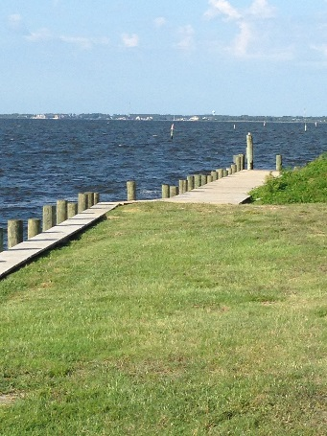
One other area that has been used a lot is the walkway out by the replaced main bulkhead. Families are enjoying fishing and crabbing from this area. The board hopes to be able to add some benches for sitting, in that area. Come take a look!
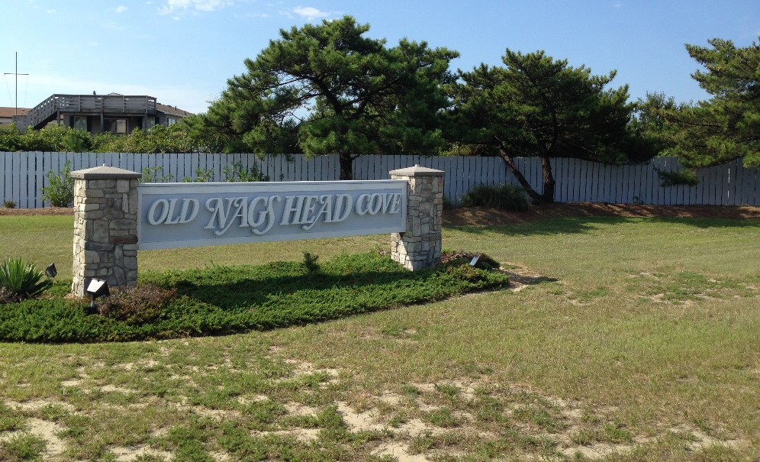
We have completed the new paint job on the main entrance fence and replaced the boards needed to be removed. Also painted the back part of the ONHC sign. And the lights have been worked on at the entrance so again, take a look and let us know what you think. The crepe myrtles at the entrance have been especially pretty this year. A nice welcome look for our neighborhood.

Your Board of Directors met in early August and those minutes can be found on the website oldnagsheadcovehoa.com. Discussion of increase in dues and boat dockage was discussed. Pursuant to Article H, Section 2 of the revised restrictive covenants the dues can only be increased by no more than 10% of the current dues of $150.00. The added monies are necessary to build a reserve fund for expenses in the future so as to not have the need for a special assessment. We know a new roof is needed in the near future and the main drain will soon need to be replaced, in the pool. Planning forward pays off!
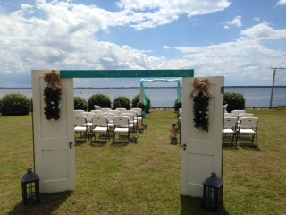
Please remember to rent the clubhouse for your functions! This is a nice clubhouse, here for your enjoyment and you might be surprised at how inexpensive it is to use for those smaller functions. However we have also had some extravagant weddings.

Real estate sales have been steady since January first. Thirteen homes and two lots have changed hands. Currently there are only six homes on the market and four lots available for sale. We have collected a number of long past due assessments with some of these transactions and others collected by sending past due notices.

In our spring newsletter we mentioned the Town allowed the Cove to continue through the summer with twice a week pick-up for trash (green can). This has been a life saver with so many homes full with summer visitors as well as rental homes. Please note however, collection will go back to one day a week beginning in September. And if you see one of the Commissioners please be sure to thank them for allowing us to have this extra service. With the heat one can imagine those shrimp peelings and other food leftovers, sitting out for seven days. Also please do not place anything for pick-up in the right-of-way until September 30. Be sure to call the town at 441-1122 and let them know you have placed something there.
As a courtesy to the Sanitation Department, if your neighbor’s trash or recycle can sits out and they are not here, please roll it back into their driveway at least. This saves time for the Sanitation worker (no need to stop if can is empty and moved) and wear and tear on the truck. Your Board of Directors can be seen pushing these back into the driveways and if you can help it really makes the street appearance so much better. And thank you if you are one of those helping!

Several junk/unlicensed cars/trailers have been removed from the Cove over the past season by the Town. There is an ordinance and one must remember how this can affect the appearance of the entire Cove as well as a nuisance to your neighbor.

One item still to be mentioned is Pets. We have available doggie bags at several areas for doggie clean-up. Take a few extra for the walk where there are none located. And remember, there is a Leash Law for all dogs. This time of the year the Nags Head Police department receives a great number of calls about dogs that are unrestrained on the beach and our neighborhoods. They ask that we let our owners in the Cove know “All dogs that are off the owner’s property must be restrained”.

LABOR DAY PICNIC IS AROUND THE CORNER, YEA!! Date is September 3, 2016 at 1 PM so plan on coming on over to the clubhouse. Hotdogs, bar-b-que, coleslaw, beans, and drinks will be provided by the Association. Please bring your favorite dish and be sure to put this on your Calendar.
The next scheduled Board of Directors meeting is November 5 at 9AM at the clubhouse. Contact a member if you wish to bring up any concerns or have comments. The meeting are open to paid members.
Enjoy the remainder of the summer and see you at the Labor Day Picnic!

